Come to the tutorial class on Week 4 with your group’s Padlet, full of problem notes.
APPENDIX B.1 – Anaylsis & Synthesis Worksheet
Human Centered Research + Creative Ideation (Analysis & Synthesis)
Activity 1 – Redefining the real problem (s)
STEP 1 – 15 mins
Login to your group’s Padlet. Analyse the list of problems identified through your video research. Shift the notes around and cluster them so that similar problems are grouped together. (Groupings can be based on any characteristics or genre. Eg. Trust issues, security, delivery options, browsing/search, layout, purchase options, customer service, payment options, timing and performance issue, after sales service.. etc)
STEP 2 – 15 mins
After grouping the problems, analyse their similarities among each group, and write down ( on this document ) one problem statements per cluster into the space below:

Problems Redefined
Example:
1. The company needs to re-examine their delivery methods so that it will be convenient for more customers
2. The website needs to have a more secure shopping cart so that customers feel safer shopping with the website.
3. The company have to be better in their customer service experience
4. The company has to enhance the users experience, by making the interface clearer to the users whom is using so they will have a more pleasurable time shopping online.
5. The company did not focus on the small details, they have only one language setting and didn’t change the currency according to the user’s country.
6. The company should make sure that the goods sent out is not defective or spoilt.
7. The website should be more private for the users so that there is privacy and secured information for the users.
8. The company's user interface has to be simple and user friendly to the users therefore it will be more easy for the customer to navigate around the web as it is hard for the customers to use various website.
9. The company have no proper specification on both the product delivery time and the quality of the product. For example the company state that the delivery time is from 7am to 6pm but did not state when is the exact timing. The buyer will then have to stay at home for that period of time

STEP 3 - 15mins
How can IT solve the above problems?
Using each of the problems identified in STEP 2, describe how IT can help solve the problem. Fill up (FOR EACH PROBLEM identified in STEP 2) in the format shown below:
Problem #: The website needs to have a more secured shopping cart so that customers feel safer shopping with the website.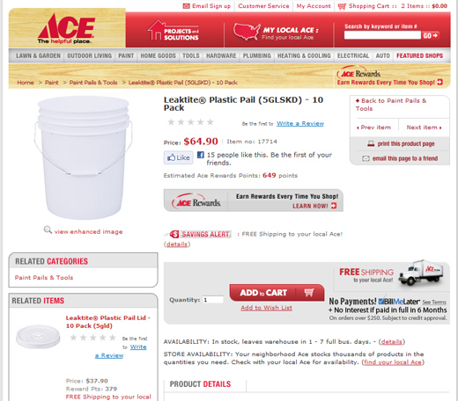
Solution:
    - Users need to rekey in password before proceed to checkout
    - Verification Security questions need to be answered
    - Captcha input feature at confirmation page
    - Credit card number validity is verified through CC card verification algorithm / or webservice

Problem 1
The company have to be better in their customer service experience. For example often we can’t get in contact with the customer hotline,when we need help on things. it’s always busy. 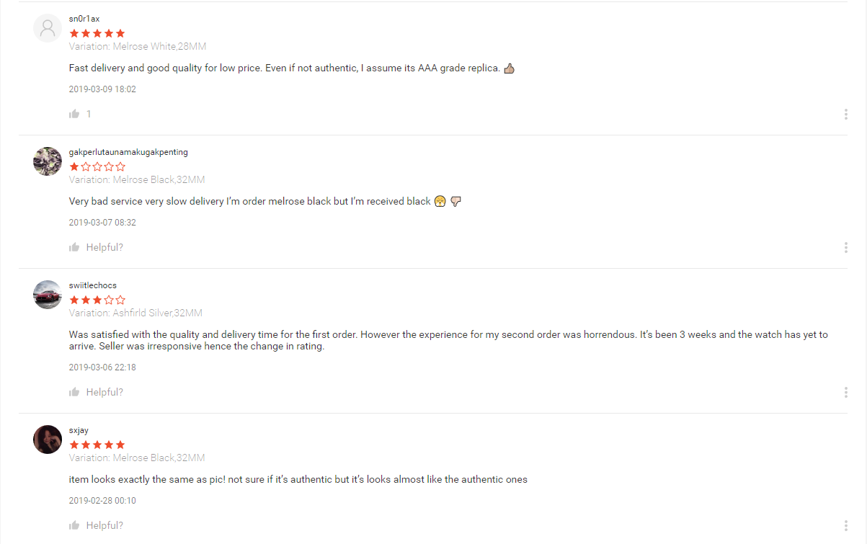
Solution:
- The company have to listen more to the customer requests and reviews
- The company must upkeep the things that they promised
- The company should have a bot that can answer User’s question.

Problem 2
The company did not focus on the small details, they have only one language setting and didn’t change the currency according to the user’s country. For example TaoBao is in chinese language, and they only accept yuan therefore it’s hard for people from Indian, French to shop on the platform.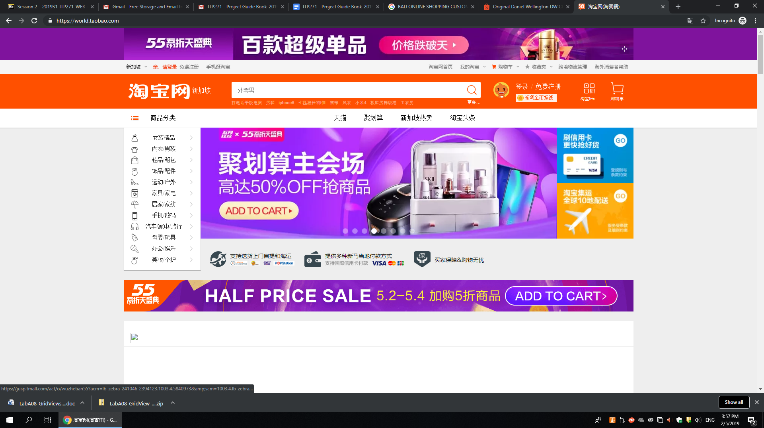

Solution:
- The company should cater the website to as much country as they can.
- For the different language user,the company can have a function like google, they can translate the whole page to the language the user want.
- The company should have a Currency Converter like what Visa did.

Problem 3
The company has to enhance the users experience, by making the interface clearer to the users whom is using so they will have a more pleasurable time shopping online. For example not too much boring information and straight to the point.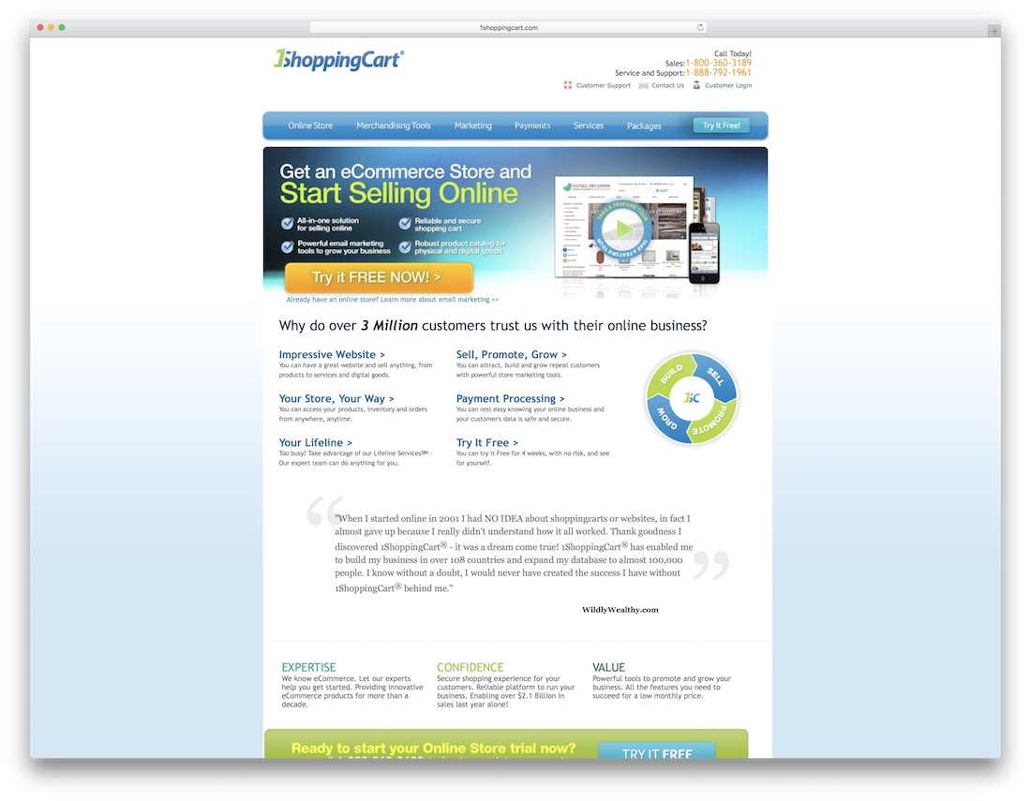
Solution:
- The company should make the website as simple as possible to that even the elderly can understand.
- The website should have fewer buttons to press and lesser pages. There should not have too much lengthy paragraphs and more pictures.
- Have more pages instead of putting all information in just one page, and use icons that are easy to understand. Also we can have a FAQ page for the user if they have any doubts on UI or buying.

Problem4
The company should make sure that the goods sent out is not defective or spoilt.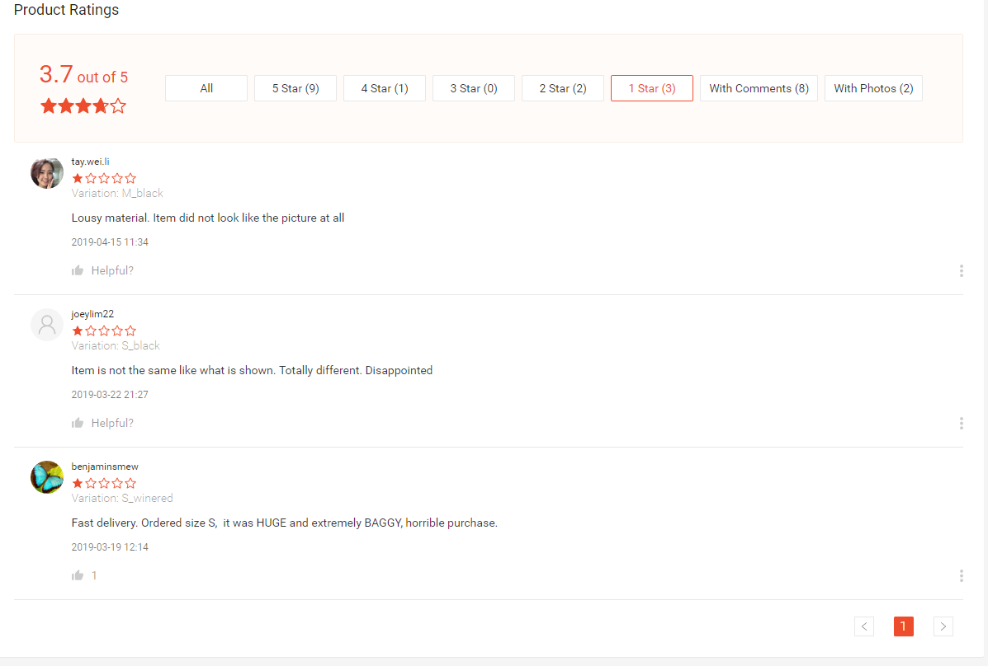
Solution:
- The company should have a quality control test before sending out the goods
- The company should facilitate the returning or refunding of goods between the buyer and the seller. For example follow up until the case have been closed.

Problem5
The website should be more private for the users so that there is privacy and secured information for the users. Examples: Attackers can perform web application attacks such as SQL injection, session hijacking, cross-site scripting, cross-site request forgery and more. These attacks can result in stolen data, authentication bypass and financial losses.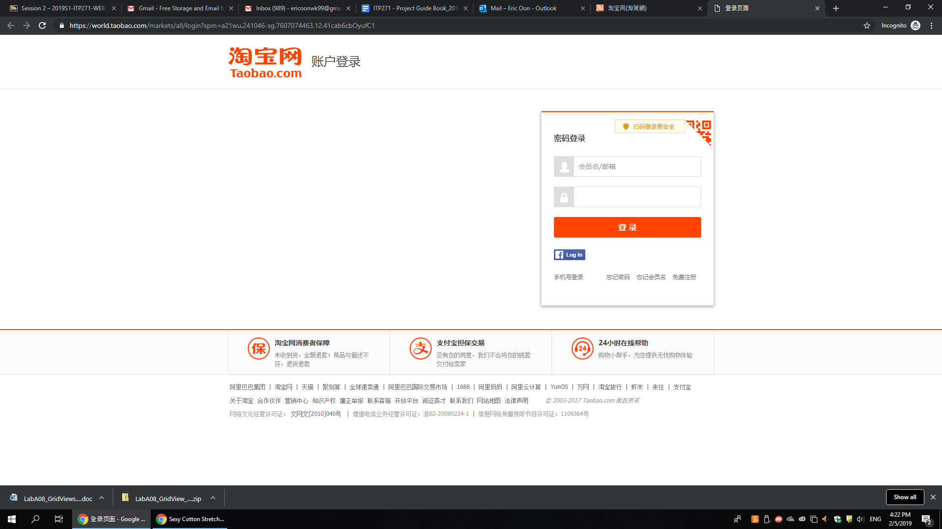
Solution:
- Make accounts for users
- Make them key in captcha when signing in
- Add input validation
- Use encryption protocols (eg. https)
- Add auto logout (session timeout)
- When entering credit cards informations or when using it the website should have 2FA confirmation.

Problem 6
The company is not clear specification on both the product delivery time and the quality of the product. For example the company state that the delivery time is from 7am to 6pm but did not state when is the exact timing. The buyer will then have to stay at home for that period of time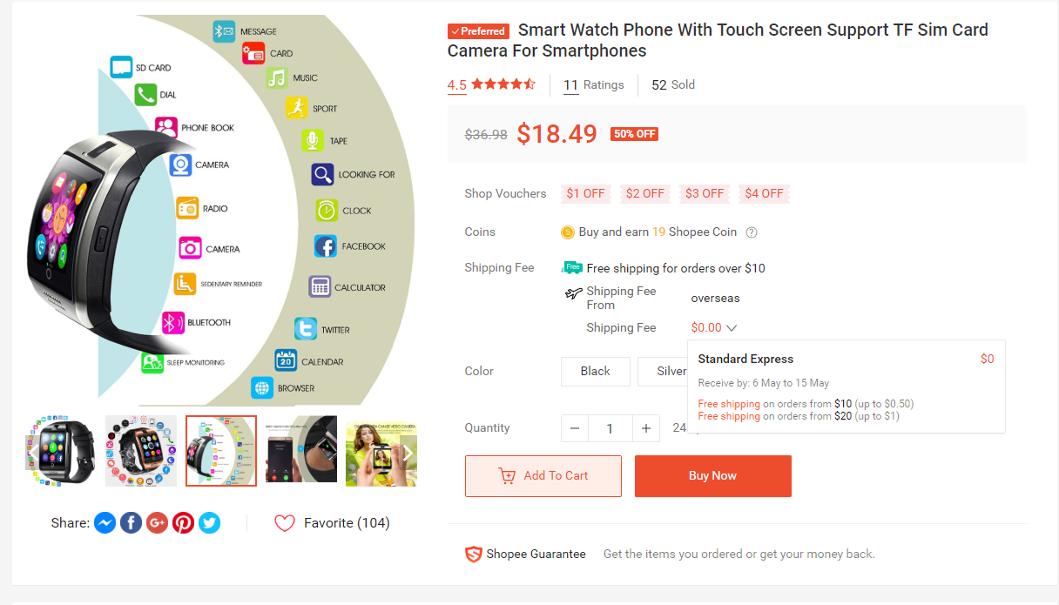
Solution:
The company should set up a product control system, like having something like a GPS to give out a signal to locate the product, this will give an accurate delivery time. while for the quality of the product we can have a refund system if there is evidence of the product did not meet the requirement .

STEP 6 – 10 mins
Prioritize the solution features and rearrange them, with the more important ones placed in front of the feature list, and less important ones behind.

